**OFFICIAL COORDINATION REQUEST FOR**

**NON-ROUTINE OPERATIONS AND MAINTENANCE**

**COORDINATION TITLE – 16 LWG 02** Lower Granite Dam Adult Ladder Return to Service Date

**COORDINATION DATE –** 8 February 2016

**PROJECT –** Lower Granite Lock and Dam

**RESPONSE DATE – FPOM Feb 11, 2016**

**Description of the problem** – The Lower Granite Dam adult ladder is currently out of service for winter maintenance and construction related activities. Currently there are multiple construction projects working in or around the adult ladder including installation of a JBS primary dewaterer drain into the Auxiliary Water Supply (AWS) pump chambers (JBS Phase 1a upgrade), Permanent Fish Ladder Temperature Improvements at the ladder exit, and installation of a new Fish Ladder Control System. In order to complete current construction activities with the JBS Phase 1a and temperature improvement projects, the Lower Granite ladder needs to be kept out of service until 23 February 2016.

**Type of outage required –** The Lower Granite Dam adult ladder will be kept out of service until 23 February 2016. The AWS pumps will be returned to service by 28 February 2016 as previously coordinated with FPOM. As such, the ladder will be returned to service prior to March 1st in accordance with the Fish Passage Plan.

**Impact on facility operation –** The adult ladder will be kept out of service until all construction and maintenance activities are completed and the ladder can be safely returned to service. It is anticipated that the ladder will be in full compliance by 1 March 2016 as required in the Fish Passage Plan.

**Dates of impacts/repairs –** The LGR adult ladder will be kept out of service through 23 February 2016 instead of 18 February 2016 as identified in the *Walla Walla District Adult Fish Passage Facilities – 2015-2016 Winter Maintenance Schedule.* The AWS pumps will be returned to service by 28 February 2016 as previously coordinated. As such, it is anticipated that the ladder will be in full compliance by 1 March 2016 as required in the Fish Passage Plan.

**Length of time for repairs –** The LGR adult ladder will be out of service for winter maintenance and construction activities 2 January to 23 February 2016. The AWS pumps will be out of service 2 January to 28 February 2016. All Lower Granite Dam adult ladder facilities are anticipated to be in full operation by 1 March 2016 as specified in the Fish Passage Plan.

**Expected impacts on fish passage –** Continuation of the current ladder outage through 23 February 2016 will delay a limited number of adult steelheads from moving through the adult ladder. The Lower Granite Ladder has historically been returned to service on or around February 28th such that there is limited data on fish attempting to pass the project prior to March 1.

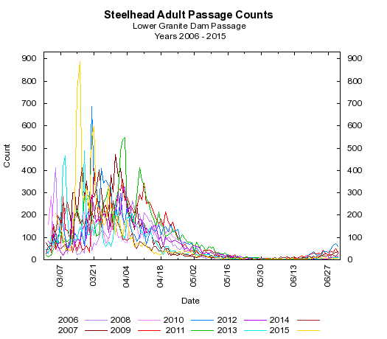

**Comments from agencies**

**Final results**

David Trachtenbarg

Fish Biologist

Environmental Analysis Section

U.S. Army Corps of Engineers

Walla Walla District

201 N 3rd Ave.

Walla Walla, WA 99362

Phone: 509-527-7238